MERG RFID
General Architecture
Block Diagram  Status | Data Concentrator  RFID Reader  Aerial  Tag
 | Data Concentrator | RFID Reader | Aerial | TAG
IFC | Purpose: Receive data from one or more readers and redistribute it in a commonly understood and well-defined format for use by established data consumers like JMRI | Purpose: Provide RF power and messaging to one or more aerials according to a well-defined industry standard protocol. Forward the received messages to the data concentrator along with an identifier as to what aerial was involved. | Purpose: Radiate the RFID energy in a detection field large enough for the model railway application but without excessive range that would result in spurious signals. | Purpose:  Receive the RF energy power up and respond back to reader via the aerial (when in range) with at minimum the manufacturer assigned GUID. Do this fast enough for reliable reads as the tag passes over the aerial at a scale locomotive speed in excess of 100 MPH.
IFC | Left Side (IN) configuration data for MQTT HUB, CBUS address, events.  Left Side (Out) MQTT+JSON and / or CBUS payloads  Right Side: I2C messages to and from RFID Reader | Left Side (IN)  I2C messages from Data Concentrator  Left Side Out: I2C Payload data {Aerial #, GUID}  Right Side: ISO/IEC 15693 RF messaging | In / Out:  ISO/IEC 15693 RF messaging | In / Out:  ISO/IEC 15693 RF messaging
IFC | TBD  (Ras Pi PICO for example) | TBD  (custom MERG board) | MOLEX  25mm x 15mm | Custom small PCB  SL2S2602FTBX IC  MLCC for Tuning
IFC | Investigating | Investigating | Lead lengths need to be matched with reader passives | Prototype designed and ordered. Parts on hand.

IFC = Issued for Comment
Designing My RFID Tag
As the design evolves regarding dimensions, number of turns, chip selection, then so dies the need for and value of a matching capacitor. Starting with the chip selection I wanted a currently Active product (not an obsolete or soon to be obsolete one). Using Application note AN11809 (A product Comparison) I quickly settled on the SLIX 2 family and specifically the SL2S2602 family. (Must use that number to search for a data sheet, do not include the packaging suffix). A specific packaging of the chip is the SL2S2602FTBX which is the desired 3 pin SMD version.
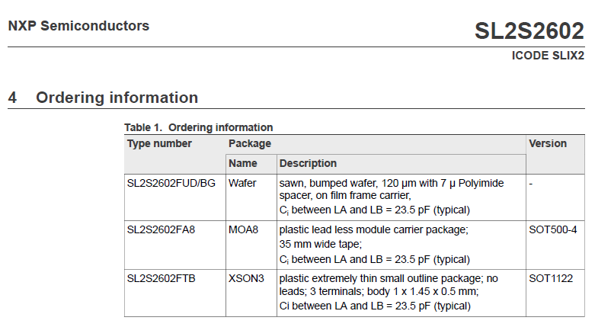
From the NXP website using the antenna calculator (link here) a matching capacitor of 42.2 pF is needed (nearest standard value is 43pF)
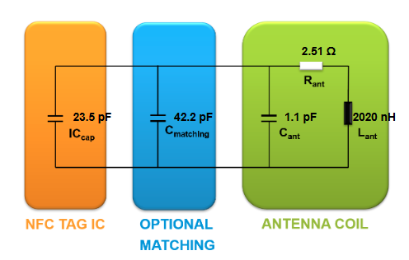
My specific design is below (created in KiCad Sept 15 2025). The tag below is 9mm x 6.5 mm on a 1mm thick FR4 PCB. There are 9 turns on each side (18 turns in total). The selected capacitor is in 0402 form (very small) and the chip is similarly tiny being in a XSON3 form factor. (see here)
Both are of course surface mount.
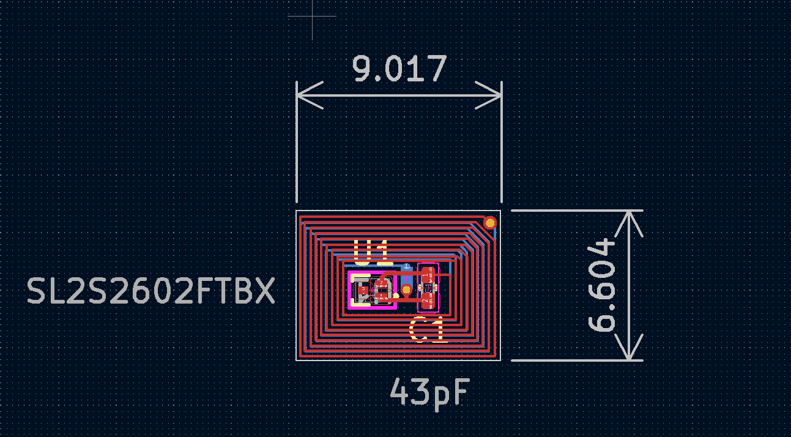

Purchase Details
Order number: Y46-4884191A

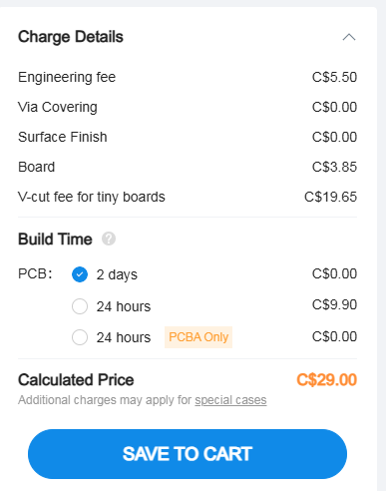
Note much higher V cut fee for tiny boards. In this case I am getting a 10 x 12 array.
(Limit for V-Cuts is 25 in each direction – so not close in that regard.)
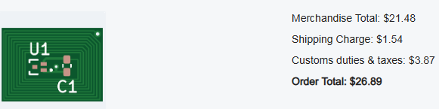

Next is to source the components:
After Google Search … Mouser Canada.

Order Number: 36928084
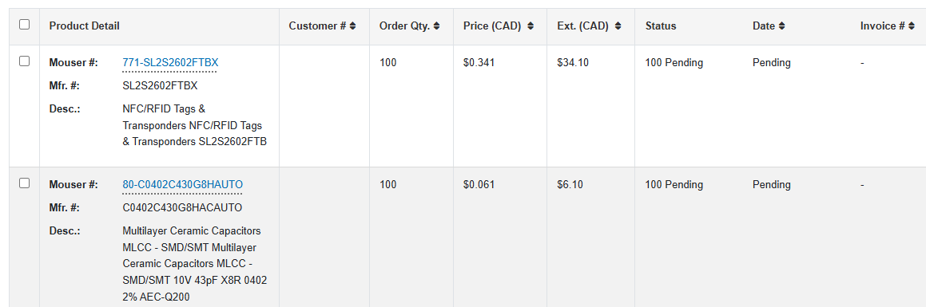
100 each of NXP chip and 0402 43pF Capacitor ($67 including $20 shipping) all in Canadian dollars.

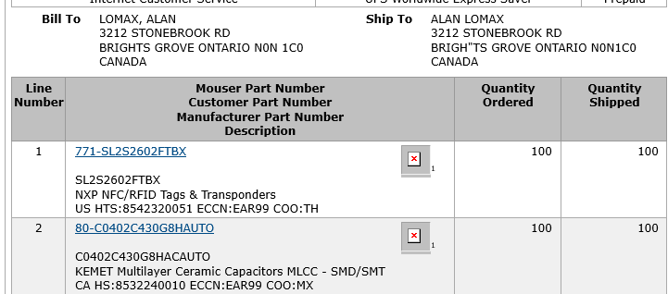

Mouser picked the parts and shipped them the same day.

On UNIT COST
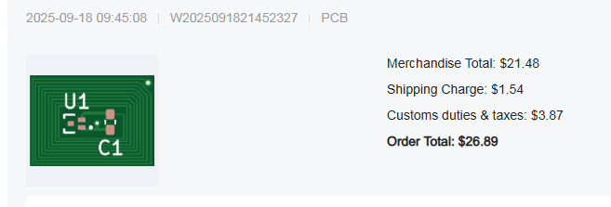
The PCB’s were about $30. Quite a bit higher than normal because there was a higher surcharge for “VeeCuts on Tiny boards”. Note – this is for Qty 5 PCBs that are 100mm x 100 mm. Each PCB has a 10x12 array of tags … so 600 tags for $30 works out to 5 cents for each Tag. The chips and capacitors were $68 Canadian for 100 of each (and $20 of that was for shipping.) so that is about $0.68 for those pieces. Per tag all in cost is 73 cents.
It would be ideal to know what the ‘assembled cost’ would be from the likes of JLCPCB as for the tags specifically I think that would be preferred.

Pre-Assembled aka ‘Stuffed’ boards
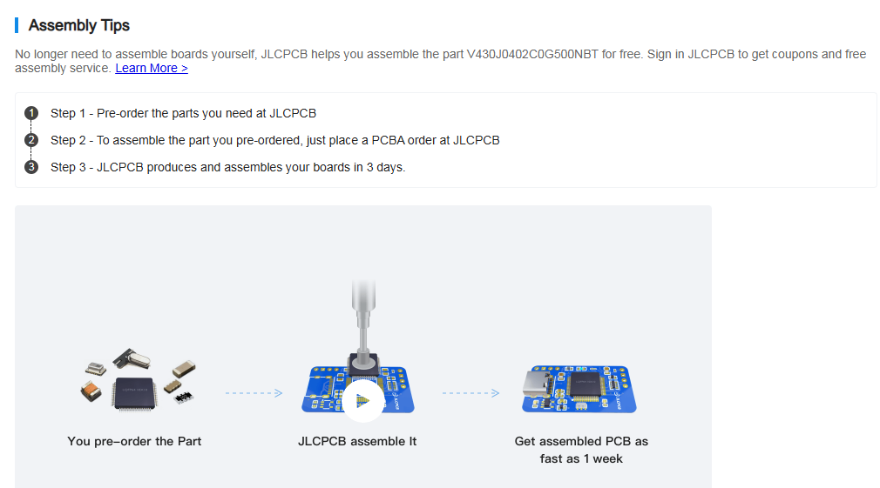

Commercial NXP Tags
(not explored yet)
Useful Network Analysis (Educational)
VSWR explained: https://www.youtube.com/watch?v=BijMGKbT0Wk
S parameters: https://www.youtube.com/watch?v=-Pi0UbErHTY
Smith Chart explained https://www.youtube.com/watch?v=rUDMo7hwihs

Common English “S term” translations
S21 – gain (Out is port 2, and in is Port 1)
S12 – noise blocking (Signal coming out of Port 1, from the port 2 side)
S11 – signal reflection (Power in on port 1 is also coming out on port 1)
S22 – signal reflection (ditto Port 2)

Build up and Testing of First Batch
Sep 30 2025
Prep | Solder paste was chosen with an indicated melt of 183 Deg C  A small dab was placed in the lid and mixed with a drop of IPA to make it smooth and creamy (was slightly grainy)  Used a solder aid tool to transfer miniscule dabs onto the solder pads.  For capacitor this was quite practical (larger pads).  For RFID chip the triad of pins were small and too close together and typically one blob covered all three.  With very fine tweezers parts were picked and verified for orientation (third pin is a tell tale) before placing on the paste.  Parts were only removed from packaging 4 at a time and only once placed were 4 more taken out of tape reel package.  The hot plate for pre heated to a pre soak temperature of 100 Deg C
Bake | The PCB with two complete rows was carefully put on the hot plate for a pre soak at 100 Deg C (5 minutes)  The temp was raised in stages with a short hold period at each (First hold was at 145 C, then 190 C and then finally temp was raised up to 205 C)  At 145 the IPA was obviously driven off – texture of solder paste changed.  At 190 some solder melt was occurring (but not the majority)  At 205C widespread melt was occurring in most places and this temperature was then held for 10 minutes.  It was noticed that one IC had popped up in the air 90 degrees to board. (In situ poking was attempted)  A close inspection then showed that capacitor on Tag 1 was MIA. A new one was retrieved from package and put in place
Cool Down | Hot plate was switched off and allowed to cool down.  The PCB was removed from the hot plate (which was warm but not hot at this stage)
Prelim Testing | Using the StaRFIshRail test rig that I have I was able to test these tags for a simple go/no-go functionality test. Of the 24 tags only 4 failed. (Awesome result in my opinion)
Next Steps | Get my MQTT client up and running  Scan the Working tags will be scanned for their UID  Inspect and repair where possible the 4 failed tags.
Oct 1
2025
 | Got my Raspberry Pi 4 up and running. It had a lot of updates to do. I reinstalled Eclipse mosquitto and it took a while to get it configured so that the HUB knew about the new IP address and that multiple clients were reading (subscribing) to it. Got there in the end.

# | Init  P/F | Next Day  GUID Read | GUID | Inspection Findings  And Comments
1 | F | No response | No response | Misaligned IC. Touch with Solder Iron Retested. Failed (3x)
2 | P |  | 09184854B8
3 | P | Failed to read | 09184854AA | Obvious paste. Touch C1 with Solder Iron Retested good
4 | P |  | 09184854B0
5 | P |  | 09184854BA
6 | P |  | 09184854AD
7 | P |  | 09184854B5
8 | P |  | 09184854BB
9 | F | No response | No response | Misaligned IC. Touch with Solder Iron Retested. Failed (3x)
10 | P |  | 09184854B1
11 | P |  | 09184854BD
12 | P |  | 09184854B2
13 | P |  | 09184854A5
14 | P |  | 09184854BC
15 | P |  | 09184854AB
16 | P |  | 09184854B7
17 | F | Failed to read | 09184854A9 | Misaligned Cap. Touch with Solder Iron Retested Good
18 | P |  | 09184854AE
19 | P |  | 09184854BE
20 | F | Failed to read | 09184854A7 | Misaligned Cap. Touch with Solder Iron Retested Good
21 | P |  | 09184854B4
22 | P |  | 09184854B9
23 | P | Failed to read | 09184854A2 | Nothing Obvious. Touch C1 with Solder Iron Retested good
24 | P |  | 09184854AC

Below is board “as completed”
- Yellow squares indicate the initial failed positions.
- Orange squares failed the following day
- After rework only 1 and 9 remained inoperable (red dashed outline)

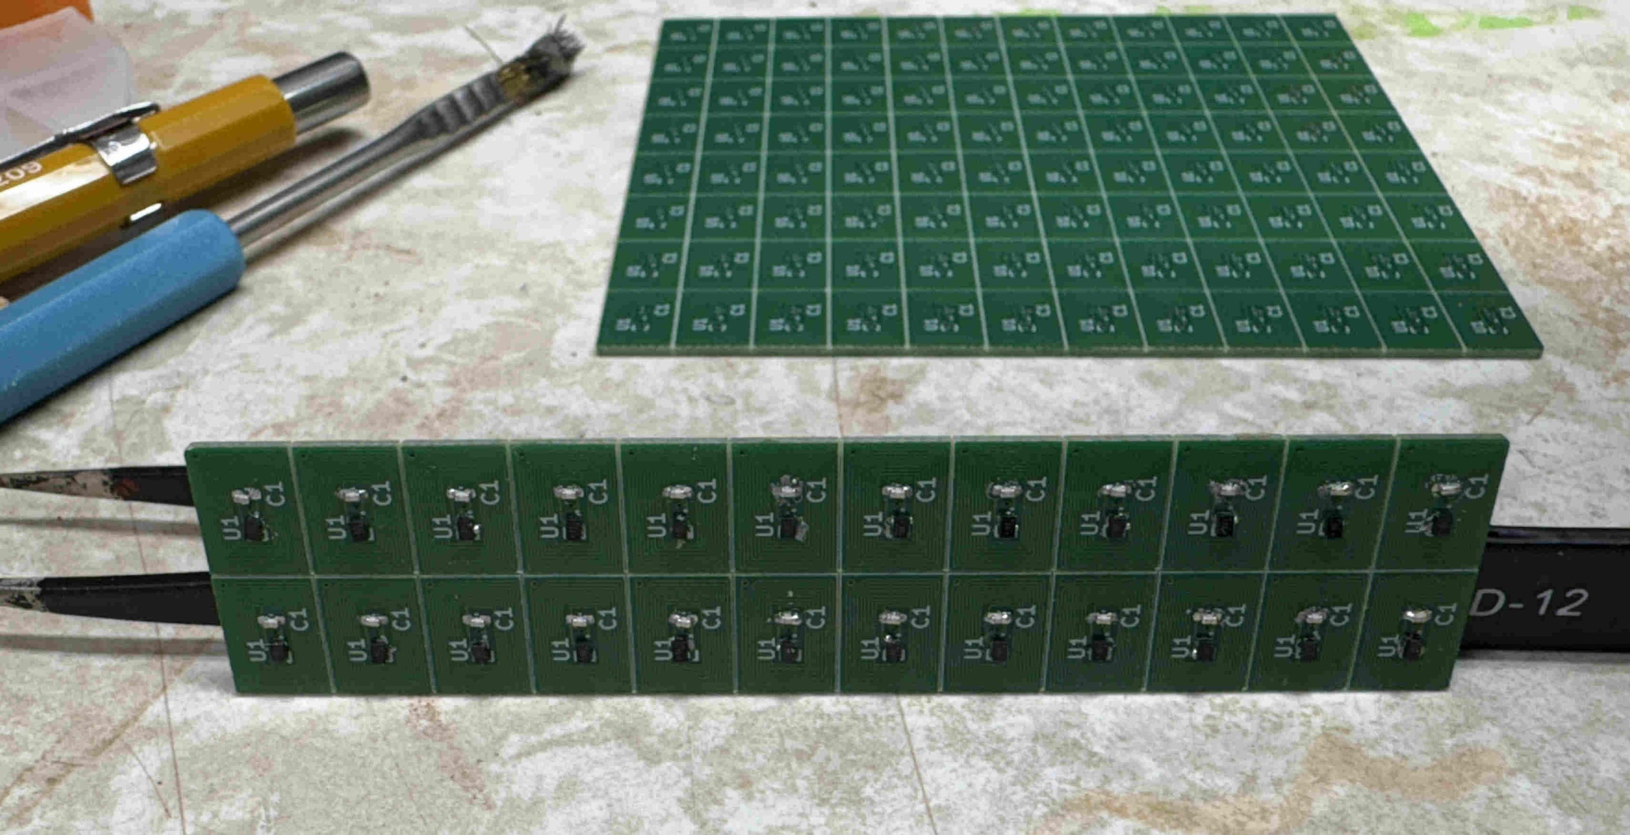
3
23
20
17
9
13
24
12
2
1

To: | David Harris  1545 York Place  Victoria, BC  Canada  V8R 5X1
Tel | 250-216-0641
Item | Qty
PCB’s | 24
Capacitor C1  (43pF 50V MLCC) | 5
NFC RFID Chip  SL2S2602FTBX | 5
Completed Boards | 5 | 6,12,14,15,24

David Harris
1545 York Place
Victoria, BC
Canada
V8R 5X1

To: | Nick Murphy  34 Droxford Crescent, Tadley, Basingstoke, Hampshire, England,  RG26 3BA
Tel
Item | Qty
PCB’s | 24
Capacitor C1  (43pF 50V MLCC) | 5
NFC RFID Chip  SL2S2602FTBX | 5
Completed Boards | 5 | 2,7,10,11,18

Mr. Nick Murphy
34 Droxford Crescent,
Tadley, Basingstoke,
Hampshire, England,
RG26 3BA

